**Chapter 1**

**Introduction to “Python”**

**1.1 Introduction to the Internship**

My Summer Training Program is on the topic “Python with Python”.

This Training aim is to teach Make an Pattern of Data That Ease the Daily Life Activity. The Technology includes: - Python , Python Libraries, Notebook, Machine Learning Algorithm . The Internship includes: - Lectures, Code-Along, Projects, Exercises, Research, Assignments, Slides, Downloads, and Readings



**Figure 1.1 Company Logo**

**1.2Basic of Python**

Python is a popular programming language. It was created by Guido van Rossum, and released in 1991.

What can Python do?

* Python can be used on a server to create web applications.
* Python can be used alongside software to create workflows.
* Python can connect to database systems. It can also read and modify files.
* Python can be used to handle big data and perform complex mathematics.
* Python can be used for rapid prototyping, or for production-ready software development.

Python Basic Implementation

Printing , Scanning, Syntax Identification, Data Type , If-else Condition , Iterative Statement,

While Loop, Do While Loop, For Loop, Function, Lambda Function , List , Tuple, Sets and

Dictionary , Arrays, Classes/object, Inheritance, Strings and Many more.

* Iterative Statement :  The iterative statements are used to execute a part of the program repeatedly as long as a given condition is True
* Function : A function is a block of code which only runs when it is called You can pass data, known as parameters, into a function . A function can return data as a result. A “Def” Keyword is Used for implementation of Function.
* Lambda Function : A lambda function is a small anonymous function. A lambda function can take any number of arguments, but can only have one expression.
* List : A list is a data structure in Python that is a mutable, or changeable, ordered sequence of elements. Each element or value that is inside of a list is called an item. Lists are defined by having values between square brackets [ ] .
* Tuple : A tuple is a collection which is ordered and unchangeable. A tuple is created by placing all the items (elements) inside parentheses () , separated by commas.
* Sets : A Set is an unordered collection data type that is iterate , mutable and has no duplicate elements. . A tuple is created by placing all the items (elements) inside curly { } , separated by commas.
* Dictionary : Dictionaries are used to store data values in key:value pairs. A dictionary is a collection which is ordered\*, changeable and do not allow duplicates.
* Classes / Objects : Python is an object oriented programming language. Almost everything in Python is an object, with its properties and methods. A Class is like an object constructor, or a "blueprint" for creating objects.
* Inheritance : Inheritance allows us to define a class that inherits all the methods and properties from another class. Parent class is the class being inherited from, also called base class.

**1.3 Libraries in Python :**

Python has created several open-source libraries, each with its root source. A library is an initially merged collection of code scripts that can be used iteratively to save time. It's similar to a physical library in that it holds reusable resources, as the name implies.

A Python library is also a group of interconnected modules. It contains code bundles that can be reused in a variety of programs. It simplifies and facilitates Python programming for programmers. Because then we won't have to write the very same code for different programs. Machine learning, computer science, data visualization, and other fields rely heavily on Python libraries.

Standard Python Libraries : Python's syntax, semantics, and tokens are all contained in the Python Standard Library. It comes with built-in modules that give the user access to basic functions like I/O and a few other essential modules. The Python libraries have been written in the C language for the most part. There are over 200 core modules in the Python standard library. Python is a powerful programming language because of all of these factors. The Python Standard Library is extremely important. Programmers won't be able to use Python's features unless they have it. Apart from that, Python has several libraries that make a programmer's life easier. Let us study some of the most popular libraries.

* Numpy : NumPy is one of the most widely used open-source Python packages, focusing on mathematical and scientific computation. It has built-in mathematical functions for convenient computation and facilitates large matrices and multidimensional data. It can be used for various things, including linear algebra, as an N-dimensional container for all types of data. The NumPy Array Python object defines an N-dimensional array with rows and columns. A long with this, it can be used as a random number generator. In Python, NumPy is recommended over lists because it uses less memory, is faster, and is more convenient.
* Pandas : Pandas is an open source library licenced under the Berkeley Software Distribution (BSD). In the domain of Python, this well-known library is widely used. They're mostly used for analysis, manipulation, and cleaning of data, among other things. Pandas allows us to perform simple data modelling and analysis without having to swap to another language like R.
* Scipy : Scipy is a Python library. It is an open-source library, especially designed for scientific computing, information processing, and high-level computing. A large number of user-friendly methods and functions for quick and convinient computation are included in the library. Scipy can be used for mathematical computations alongside NumPy. Cluster, fftpack, constants, integrate, io, linalg, interpolate, ndimage, odr, optimise, signal, spatial, special, sparse, and stats are just a few of the subpackages available in SciPy.
* SciKit – Learn : Scikit-learn is also an open-source machine learning library based on Python. Both supervised and unsupervised learning processes can be used in this library. Popular algorithms and the SciPy, NumPy, and Matplotlib packages are all already pre-included in this library. The most well-known Scikit-most-learn application is for Spotify music recommendations.
* Seaborn : Scikit-learn is also an open-source machine learning library based on Python. Both supervised and unsupervised learning processes can be used in this library. Popular algorithms and the SciPy, NumPy, and Matplotlib packages are all already pre-included in this library. The most well-known Scikit-most-learn application is for Spotify music recommendations.
* Tensor Flow : TensorFlow is an open-source numerical calculation library with high performance. Deep learning and ML algorithms make use of it as well. It was developed by Google Brain group researchers inside the Google AI organisation and is now widely used for complex mathematical computations by mathematics, physics, and also machine learning researchers.
* Scrapy : Scrapy is a web scraping tool that scrapes multiple pages in under a minute. Scrapy is also an open-source Python library framework for extracting data from websites. Under the name "Scrapinghub ltd," it is a high-speed, high-level scraping and crawling web library.
* PyGame : This library provides a simple interface for the graphics, audio, and input libraries of the Standard Directmedia Library (SDL) which can work on any platform. It's used to make video games with the Python programming language and computer graphics and acoustic libraries.
* StatsModel : Statsmodels is a Python library that helps with statistical model analysis and estimation. The library is used to run statistical tests and other tasks, resulting in high-quality results. The user-friendly interface The Python programming language is widely used in many real-world applications. It is expanding rapidly in the sectors of error debugging since it is a high-level language that is dynamically written. Python is becoming more widely used in widely famous applications like YouTube and DropBox. Users can also perform multiple tasks without needing to type their code, thanks to the accessibility of Python libraries.

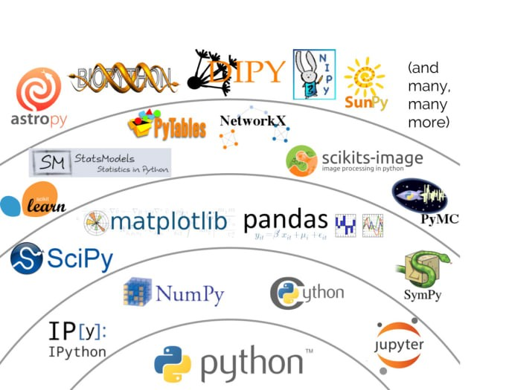

**Figure 1.3 Python Libraries**

**1.4 Task 1 (Understanding with python):**

1.Write a python program for merge two excel file data to one file

Write a python program to shorting file in different folder means main folder containing 50 word file. Now after shorting create 4 child folder and store 12 or 13 file each folder.

2.Write a python program separate duplicate file.

Check with mobile number in main excel file and test data docs and if it is same or equal create seperate file and store duplicate file data

3.Write a python program for Shorting file by keywords.

input: folder path = text value

Create new folder=text value

Search Keyword= text value

Output: Create folder with input value and inside folder all shorting files displaying

**1.5 Task 2 (Generating EDA for Analysing Data):**

Create EDA using Test Data file(Yoshops.com Sale Order file) :

Input Value for generate Graph chart:

Enter 1 to see the analysis of Reviews given by Customers

Enter 2 to see the analysis of different payment methods used by the Customers

Enter 3 to see the analysis of Top Consumer States of India

Enter 4 to see the analysis of Top Consumer Cities of India

Enter 5 to see the analysis of Top Selling Product Categories

Enter 6 to see the analysis of Reviews for All Product Categories

Enter 7 to see the analysis of Number of Orders Per Month Per Year

Enter 8 to see the analysis of Reviews for Number of Orders Per Month Per Year

Enter 9 to see the analysis of Number of Orders Across Parts of a Day

Enter 10 to see the Full Report

Enter the number to see the analysis of your choice: 1

Output : Generate analysis report in format PDF and Excel file

**1.5 Reason for Selecting Python:**

Data is meaningless until its conversion into valuable information. Python involves mining large datasets containing structured and unstructured data and identifying hidden patterns to extract actionable insights. The importance of Python lies in its innumerable uses that range from daily activities like asking Siri or Alexa for recommendations to more complex applications like operating a self-driving car.

The interdisciplinary field of Python encompasses Computer Science, Statistics, Inference, Machine Learning algorithms, Predictive Analysis, and new technologies.

**1.6 History of Python**

The term “Python” was created in the early 1960s to describe a new profession which would support the understanding and interpretation of the large amounts of data which was being amassed at the time. (At the time, there was no way of predicting the truly massive amounts of data over the next fifty years.) Python continues to evolve as a discipline using computer science and statistical methodology to make useful predictions and gain insights in a wide range of fields. While [Python](http://www.dataversity.net/what-is-data-science/) is used in areas such as astronomy and medicine, it is also used in business to help make smarter decisions.

Statistics, and the use of statistical models, are deeply rooted within the field of Python. Python started with statistics, and has evolved to include concepts/practices such as artificial intelligence, machine learning, and the Internet of Things, to name a few. As more and more data has become available, first by way of recorded shopping behaviors and trends, businesses have been collecting and storing it in ever greater amounts. With growth of the Internet, the Internet of Things, and the exponential growth of data volumes available to enterprises, there has been a flood of new information or [big data](http://www.dataversity.net/what-is-big-data/). Once the doors were opened by businesses seeking to increase profits and drive better decision making, the use of big data started being applied to other fields, such as medicine, engineering, and social sciences

**1.7 Outcome of Internship**

With its footprint in practically every industry, Python job-demand is estimated to rise several-fold in the future. The importance of Python is growing with every coming day. Jigsaw Academy offers various quality Python courses to train tomorrow’s Data Scientists. Learners can enroll in the [Full Stack Python Program (FSDS)](https://www.jigsawacademy.com/full-stack-data-science-program-online/) if they are looking for a comprehensive Full Stack Python program. This 6-month-long online program is an industry recommended and validated course aligned to the SSC NASSCOM curriculum.

**Figure 1.7 Python**

**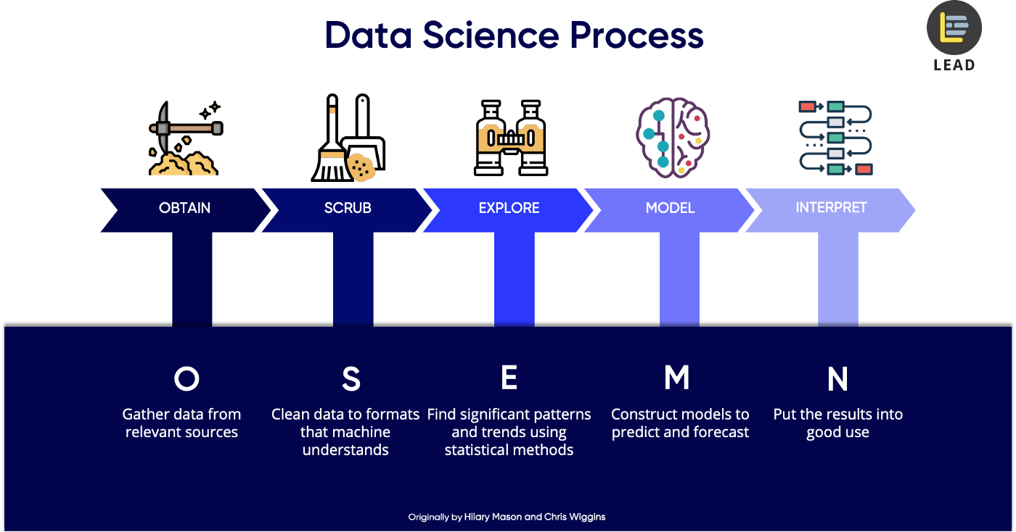**

**Chapter 2**

**Training Company “Yoshops Pvt. Ltd.”**

**2.1 About Yoshops Ecommerce**

Welcome to Yoshops, your number one shopping site for all things bags, led, TV, drones, mobile accessories, bags, laptop, mobiles, phones, laptop accessories, iron box, mixer, grinder, juicer, toys, headphones, computer peripherals.

**Vision:** Yoshops idea is to create India’s most fair and reasonable price E-commerce ecosystem that creates life-changing experiences for buyers and sellers.

**Team:** In September 2016 Lipika Rani([Linkdin Profile](https://www.linkedin.com/in/lipika-sahu-a256ba1ab/" \t "_blank)), Prabeen Kumar Patra([Linkdin Profile](https://www.linkedin.com/in/prabeen-kumar-patra-081b9a8/" \t "_blank)) and Subasis Das([Linkdin Profile](https://www.linkedin.com/in/subasis-das-6132a9165/" \t "_blank)) started  Yoshops.com

**Mentors: Still Searching**

**Customer:**Yoshops  is the shopping destination for Internet users across the  India. In its journey till now Yoshops  is the preferred choice of thousands of online shoppers given products, quick delivery even to the remotest corners of the country, and daily deals, coupon& offers to make products available at slashed down prices to our valuable customers. Get Started! Shop Online Today at Yoshops.

**Sell On Yoshops:** Shopping online particularly at Yoshops  is  all you need is a mobile phone or laptop or tablet with Internet connection to get started. Simply log into Yoshops .com and browse through the wide range of products across categories. Once you have your favourite products, simply place the order by filling in the details the products will be delivered right at your doorstep. Fulfil Your Entrepreneurial Dreams! Sell Today at Yoshops  Thanks to easy-to-understand, flexible policies and SD Advisers to help sellers at each step, anyone from a manufacturer to wholesaler to retailer can sell on Yoshops . Begin your entrepreneurial journey with Yoshops  as a seller by filling a simple registration form here. Once the registration process is done, you can start selling your products to the entire country by sitting at your home or office. Doesn't it sound thrilling? Of course, it is and the excitement will build up with every order you receive! Start selling at Yoshops  today and see your business reach staggering heights.

**About Product List**

Online Sale for Women Bags at yoshops.com Buy Women Bags ,man Bags ,kids Bags on discount, Free Shipping, Cash on Delivery in yoshops.com, Low, Prices, Lowest Prices Huge Selection, Easy Returns  available, handbags for women online on yoshops.com. Shop for ladies handbags, gents bags and purses from top brands like Lavie, Hidesign, Caprese, Bags, Wallets & Luggage in yoshops. com, A complete bag store that offers stylish Luggage, Backpacks, Handbags, Laptop Bags, trendy Briefcases, Messenger Bags, Duffle Bags, Travel Accessories, School Bags, Wallets and Belts Buy Bags for Women and Men Online at Best Prices in India - Shop list of Bags with best price in India at yoshops.com. yoshops.com : Online shopping for makeup and nails from all your favorite brands of beauty products in the Beauty Store, Buy Cosmetics, Bridal Makeup online at low prices in India. Shop online for Beauty Products - Lipstick, Kajal, Mascara, Eye Liner, Lip Gloss in yoshops.com, Buy cosmetics & beauty products online from Nyka, the online shopping beauty store. Browse makeup, health products & more from top beauty brands in yoshops.com, Shop the latest make up trends with free delivery on every order at Beauty Bay. Browse eye shadow, lipstick, mascara and more from the top beauty brands in yoshops.com, Women's Beauty Products online in India. Select from the best range of Make Up Products for women at yoshops.com ? free shipping\* ? Cash on Delivery. Buy Books online at low prices in India, Children's Books, Travel book, Economics book, Audio-books, cooking-books, Arts Books & more from yoshops.com Get Free Shipping & COD. Buy, Rent & Sell Residential, Commercial & Agricultural properties in yoshops.com.yoshops.com offers to buy dhals, rice, sugar, pulses, millets, spices, pickles, baby products, MTR, Sakthi, ashirvad, annapurna, pillsbury, idhayam, tata salt, udhayam, Fresh Fruits & Vegetables, Kitchen & Dairy Products, Home Care & Personal Care, Soft Drinks in yoshops.com, Free Shipping, COD. Fashion Jewellery, artificial jewellery, designer jewellery, Women's Jewellery, Fancy Jewellery Online in yoshops.com, Women Fashion Jewellery at yoshops.com, We offer wide range of jewellery for women, Men, Kids, necklaces, earrings, bracelets, bangles in  Free Shipping, COD on yoshops.com. Watches for men at best prices in India from Casio, Fastrack, Fossil and more popular brands in yoshops.com. Designer Watches, Sports Watches, Wrist Watches, Ana log Watches For Men and Women in yoshops.com. Buy Tablet, mobile  online at low price in India on Yoshops.com. Free Shipping. Cash On Delivery. Free Shipping, Cash on Delivery, Low Prices · Huge Selection · Easy Returns · 100% Purchase Protection Types: Adaptors & Cables, Memory Card, External Hard Drives, Pen Drives, Keyboard & Mouse Sets, Find great deals on yoshops for Cheap Laptops in PC Laptops and Netbooks. Buy Computer, Laptops, Pen Drives, Accessories & more at best prices in India at yoshops.com. Check out Computer Store online. Get Free mouse. Replace your old PC or even an out-dated laptop and make way for a cutting-edge laptop, which can be easily bought online at yoshops.com .The laptop e-store at yoshops.com. Buy Latest Laptops at India's Best Online Shopping Store. Check reviews of the product and Price for Laptops in India and Buy Online. Free Shipping.Buy Personal & Professional Business Laptops as well as Gaming.Laptops. Free delivery & returns online.Buy laptops online from Croma Retail with great offers such as COD and express delivery. Buy laptops, mini tops from HP, Lenovo, Acer. Shop for Sony Viao. Buy Laptops from popular brands - HP, Dell, Lenovo, Ace rout of 5 stars The cheapest Windows 10 Laptop in India.Shop online for electronics, photos, electronic accessories and more at low prices in india on yoshops.com. Shop for home and kitchen electronics appliances online  Shopping with yoshops, get best price deals on wide range of branded latest products with free Shop online for electronics, photos, electronic accessories and more at low prices in india on Yoshops. ELECTRONICS ONLY ON YOSHOPS. Electronics Best Sellers Mobile Phones Mobile Accessories Laptops Tablets Computers & Accessories Television Audio & Home Entertainment Cameras yoshops Exclusive.Buy men,kid,Women clothing online at low prices in India. Browse.women ethnic wear, intimate wear, plus size women clothing in yoshops.Latest fashion trends in online shopping in India for branded shoes, clothing, dresses, handbags, watches, home decor & accessories for men & women in yoshops.com.

**Chapter 3**

**Statistic For Python**

**3.1 Requirement of Statistic for Python**

Statistical analysis and probability influence our lives on a daily basis. Statistics is used to predict the weather, restock retail shelves, estimate the condition of the economy, and much more. Used in a variety of professional fields, statistics has the power to derive valuable insights and solve complex problems in business, science, and society. Without hard science, decision making relies on emotions and gut reactions. Statistics and data override intuition, inform decisions, and minimize risk and uncertainty.

In Python, statistics is at the core of sophisticated machine learning algorithms, capturing and translating data patterns into actionable evidence. Data scientists use statistics to gather, review, analyze, and draw conclusions from data, as well as apply quantified mathematical models to appropriate variables. Data scientists work as programmers, researchers, business executives, and more. However, what all of these areas have in common is a basis of statistics. Thus, statistics in Python is as necessary as understanding programming languages.

Statistical functions are used in Python to analyze raw data, build data models, and infer results. Below is a list of the key statistical terms:

* Population: the source of data to be collected.
* Sample: a portion of the population.
* Variable: any data item that can be measured or counted.
* Quantitative analysis (statistical): collecting and interpreting data with patterns and data visualization.
* Qualitative analysis (non-statistical): producing generic information from other non-data forms of media.
* Descriptive statistics: characteristics of a population.
* Inferential statistics: predictions for a population.
* Central tendency (measures of the center): mean (average of all values), median (central value of a data set), and mode (the most recurrent value in a data set).

**3.2 Classification of Statistics**

* Descriptive Statistics : Descriptive statistics are used to describe the characteristics or features of a dataset. The term ‘descriptive statistics’ can be used to describe both individual quantitative observations (also known as ‘summary statistics’) as well as the overall process of obtaining insights from these data. We can use descriptive statistics to describe both an entire population or an individual sample. Because they are merely explanatory, descriptive statistics are not heavily concerned with the differences between the two types of data.
* Inferential Statistics : Inferential statistics is a branch of statistics that makes the use of various analytical tools to draw inferences about the population data from sample data. Apart from inferential statistics, descriptive statistics forms another branch of statistics. Inferential statistics help to draw conclusions about the population while descriptive statistics summarizes the features of the data set.

**3.3 Measure of Central Tendency**

A measure of central tendency is a single value that attempts to describe a set of data by identifying the central position within that set of data. As such, measures of central tendency are sometimes called measures of central location. They are also classed as summary statistics. The mean (often called the average) is most likely the measure of central tendency that you are most familiar with, but there are others, such as the median and the mode.

* Mean (Arithmetic) : The mean (or average) is the most popular and well known measure of central tendency. It can be used with both discrete and continuous data, although its use is most often with continuous data
* Mode : The mode is the most frequent score in our data set. On a histogram it represents the highest bar in a bar chart or histogram.
* Median : the median is the value separating the higher half from the lower half of a data sample, a population, or a probability.

**3.5 Measure of Variability**

[Range](https://www.scribbr.com/statistics/range/)**:** the difference between the highest and lowest values

[Interquartile range](https://www.scribbr.com/statistics/interquartile-range/)**:** the range of the middle half of a distribution

[Standard deviation](https://www.scribbr.com/statistics/standard-deviation/)**:** average distance from the mean

[Variance](https://www.scribbr.com/statistics/variance/)**:** average of squared distances from the mean

**3.6 Measure of Relationship**

 The statistical measures which show a relationship between two or more variables are called Measures of Relationship. Correlation and Regression are commonly used measures of relationship

* Covariance : Covariance is the measure of the joint variability of two random variables (X, Y). For Example – Income and Expense of Households. The households having higher Income (say X) will have relatively higher Expenses (say Y) and vice-versa. This kind of relationship between two variables is called joint variability and is measured through Covariance and Correlation
* Correlation : : To measure both the strength and direction of the linear relationship between two variables, we use a statistical measure called correlation
* Regression : Regression is a statistical method used in finance, investing, and other disciplines that attempts to determine the strength and character of the relationship between one dependent variable (usually denoted by Y) and a series of other variables (known as independent variables)

**3.7 Measure of Accuracy**

Accuracy and precision are two measures of observational error. Accuracy is how close a given set of measurements are to their true value, while precision is how close the measurements are to each other. In other words, precision is a description of random errors, a measure of statistical variability.

**Figure 3.7 Statistics**

**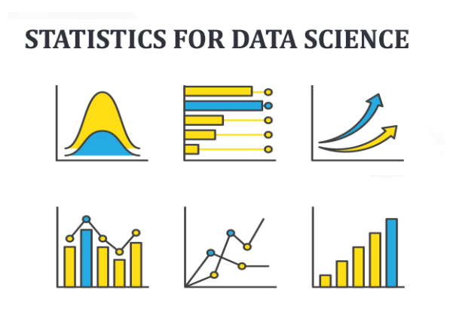**

**Chapter 4**

**Tools used in Python**

**4.1 Data Extraction and Transformation Tools:**

Data extraction and transformation tools are software applications that are designed to extract data from various sources, transform the data into a format that is suitable for analysis, and load the transformed data into a target system or database.

These tools are commonly used in data integration and ETL (Extract, Transform, Load) processes, which involve collecting data from multiple sources, cleaning and transforming it, and then loading it into a data warehouse or other target system.

Data extraction and transformation tools can automate these processes, making them more efficient and less error-prone. They can handle a variety of data formats, including structured, semi-structured, and unstructured data, and can integrate with a wide range of data sources, such as databases, cloud services, web services, and files.

**4.2 Type of Data Extraction and Transformation:**

Data extraction and transformation tools are software applications that are used to extract data from various sources, transform it into a format that is suitable for analysis, and load it into a target system or database. There are several types of data extraction and transformation tools available, including:

* **Open-source tools:** These are tools that are available for free and are typically developed and maintained by a community of developers. Examples of open-source data extraction and transformation tools include Apache NiFi, Apache Spark, and Talend.
* **Commercial tools:** These are tools that are developed and sold by software vendors. Commercial data extraction and transformation tools often have more features and support than open-source tools, but they can also be more expensive. Examples of commercial data extraction and transformation tools include Alteryx and Informatica.
* **Cloud-based tools:** These are tools that are hosted in the cloud and accessed through a web browser. Cloud-based data extraction and transformation tools often have a pay-as-you-go pricing model and can be more cost-effective for small to medium-sized businesses. Examples of cloud-based data extraction and transformation tools include AWS Glue, Google Cloud Dataflow, and Microsoft Azure Data Factory.
* **Self-service tools:** These are tools that are designed to be used by non-technical users. Self-service data extraction and transformation tools often have a visual interface and drag-and-drop features that make it easy for users to extract and transform data without having to write code. Examples of self-service data extraction and transformation tools include Power BI and Tableau.

Overall, the choice of data extraction and transformation tool will depend on factors such as the size and complexity of the data, the level of technical expertise required, and the budget available for software.

**4.3 API Integration tools:**

API integration tools are software applications that are used to integrate different software systems and services by connecting their application programming interfaces (APIs). APIs are sets of protocols, routines, and tools that are used to build software applications and allow different applications to communicate with each other.

API integration tools can be used to connect different systems and services, such as cloud storage, e-commerce platforms, social media platforms, and messaging services. These tools can simplify the integration process by providing a user-friendly interface that allows developers and non-technical users to configure and manage API connections without having to write code.

API integration tools typically provide a range of features, such as:

* **API management:** This includes features such as API documentation, monitoring, security, and analytics.
* **Data mapping and transformation:** This includes features that allow data to be mapped between different systems and transformed to meet the requirements of the target system.
* **Workflow automation:** This includes features that allow the creation of workflows and automation of business processes using APIs.
* **Customization:** This includes features that allow customization of the API integration tool to meet the specific needs of the organization.

Some popular API integration tools include Zapier, Workato, Tray.io, Dell Boomi, and Mulesoft Anypoint Platform. These tools offer various features and capabilities, such as pre-built integrations, custom integrations, and enterprise-level support. The choice of API integration tool will depend on factors such as the size and complexity of the organization, the types of systems and services that need to be integrated, and the level of technical expertise available.

**4.4** **Notification tools:**

Notification tools are software applications that are designed to send alerts, notifications, and messages to users through various channels such as email, SMS, mobile push notifications, and in-app notifications. These tools are commonly used in business, marketing, and customer service applications to keep users informed and engaged.

Notification tools typically provide a range of features and capabilities, including:

* **Multi-channel messaging:** This includes features that allow notifications to be sent through various channels such as email, SMS, mobile push notifications, and in-app notifications. This ensures that users receive notifications through their preferred channel.
* **Personalization:** This includes features that allow notifications to be personalized based on user preferences, behavior, and demographics. Personalized notifications can help increase user engagement and drive conversions.
* **Automation:** This includes features that allow notifications to be triggered automatically based on user actions, such as completing a purchase or abandoning a shopping cart. Automation can help save time and increase efficiency.
* **Segmentation:** This includes features that allow users to be segmented based on various criteria such as location, behavior, and demographics. Segmentation can help ensure that notifications are targeted to the right audience.

Reporting and analytics: This includes features that allow users to track the performance of notifications and measure metrics such as open rates, click-through rates, and conversions. Reporting and analytics can help users optimize their notification campaigns for better results.

**4.5 Types of Notification tools used in Price Tracker:**

Notification tools are essential components of a price tracker project. A price tracker project involves monitoring the prices of products or services on different e-commerce platforms and alerting users when there are changes in price.

The notification tools used in a price tracker project should be able to send alerts to users in real-time when there are changes in price. The following are some examples of notification tools that can be used in a price tracker project:

* **Email notifications:** Email notifications can be used to alert users of price changes. Email notifications are reliable, and they can be sent automatically when there is a price change.
* **Mobile push notifications:** Mobile push notifications can be used to alert users of price changes on their mobile devices. Mobile push notifications are convenient because users can receive alerts even when they are not using the price tracker application.
* **SMS notifications:** SMS notifications can be used to alert users of price changes. SMS notifications are useful when users do not have access to the internet or email.
* **In-app notifications:** In-app notifications can be used to alert users of price changes when they are using the price tracker application. In-app notifications are useful because users can receive alerts without leaving the application.

Notification tools used in a price tracker project should also have the following features:

**Customization:** Notification tools should allow users to customize the frequency and type of alerts they receive. Users should be able to choose which products or services they want to track and how often they want to receive alerts.

**Automation:** Notification tools should be able to send alerts automatically when there are changes in price. Users should not have to manually check for price changes.

**Multi-channel messaging:** Notification tools should allow users to receive alerts through different channels such as email, SMS, and mobile push notifications. This ensures that users receive alerts through their preferred channel.

Some examples of notification tools that can be used in a price tracker project include Zapier, IFTTT, and Twilio. These tools allow users to automate the sending of alerts when there are price changes and offer multi-channel messaging options. The choice of notification tool will depend on factors such as the size and complexity of the price tracker project and the budget available for software.

**4.6 Version Control Tools:**

Version control tools are software applications used by developers to manage changes to source code or other files in a software project. These tools allow developers to track changes made to files over time, collaborate with others on a project, and revert to previous versions of files if needed.

Version control tools are essential in software development because they help developers keep track of changes made to source code or other files, which can be critical in identifying and fixing bugs or errors. They also help ensure that different developers working on the same project can collaborate effectively and avoid conflicts that can arise when multiple people are working on the same code simultaneously.

There are two main types of version control tools: centralized and distributed.

Centralized version control tools, such as Apache Subversion (SVN), use a central repository to store files and track changes made by developers. Developers check out files from the central repository to make changes, and then check them back in when they are done. The central repository acts as a single source of truth for the project, and developers can easily see who made changes and when.

Distributed version control tools, such as Git and Mercurial, allow developers to create a local copy of the repository on their own computer. Developers can make changes to files locally and then push their changes back to the central repository when they are ready. This approach allows developers to work independently without needing to be connected to the central repository at all times.

Version control tools offer several benefits for developers and software projects, including:

* **Collaboration:** Version control tools make it easier for developers to work together on a project, whether they are working on the same code simultaneously or at different times.
* **Change tracking:** Version control tools allow developers to track changes made to files over time, making it easier to identify and fix bugs or errors.
* **Code review:** Version control tools make it easier to review changes made by other developers, allowing for better code quality and consistency.
* **Branching and merging:** Version control tools allow developers to create separate branches of code to work on new features or fixes, and then merge those branches back into the main codebase when they are ready.
* **Versioning:** Version control tools allow developers to maintain a history of changes made to files over time, making it easier to revert to previous versions if needed.

Some popular version control tools include Git, SVN, Mercurial, and Perforce. These tools offer various features and capabilities, such as branching and merging, code review, and integration with other software development tools. The choice of version control tool will depend on factors such as the size and complexity of the software project and the preferences of the development team.

**4.7 Git & Git Hub**

Git is a distributed version control system that is commonly used for managing source code changes in software development projects. It was created by Linus Torvalds in 2005 and is now widely used by software developers around the world. Git allows developers to track changes to their codebase, collaborate with others, and manage different versions of their codebase.  
  
Git is a distributed version control system, which means that every developer has their own copy of the codebase on their local computer. This allows developers to work independently and make changes to the codebase without interfering with each other. Developers can also share changes with others by pushing their changes to a shared repository, such as GitHub.  
  
GitHub is a web-based hosting service for Git repositories. It provides a platform for developers to store, manage, and collaborate on their Git repositories. GitHub provides a user-friendly interface for managing Git repositories and allows developers to track issues, pull requests, and other aspects of the software development process.  
  
GitHub provides a number of features that make it a popular choice for software development projects, including:

* **collaboration:** GitHub makes it easy for developers to collaborate on a project by providing tools for code review, issue tracking, and pull requests.
* **Public and private repositories:** GitHub allows developers to create public and private repositories, so they can share their code with the world or keep it private.
* **Integration with other tools:** GitHub can be integrated with other software development tools,such as continuous integration and deployment tools, making it easier to manage the software development process.
* **Social features:** GitHub has a social aspect to it, allowing developers to follow each other, discover new projects, and contribute to open-source projects.

Overall, Git and GitHub are powerful tools for managing source code changes in software development projects. They offer a range of features for collaboration, version control, and project management, making them essential tools for developers working on software projects of all sizes.

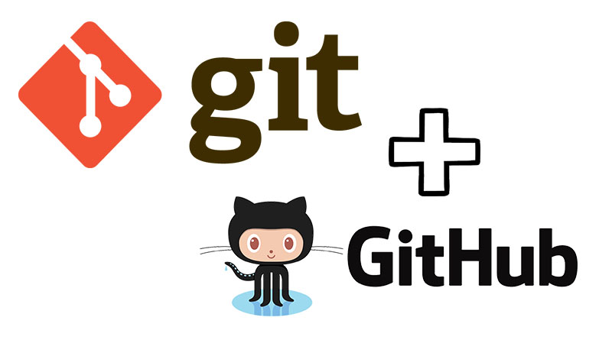

**Figure 4.7 Git & Git Hub**

**Chapter 5**

**Web Scrapping For Python**

**5.1 Introduction to Web Scrapping**

Web scraping is a technique for extracting information from websites. This can be done manually but it is usually faster, more efficient and less error-prone to automate the task.

Web scraping allows you to acquire non-tabular or poorly structured data from websites and convert it into a usable, structured format, such as a .csv file or spreadsheet.

Scraping is about more than just acquiring data: it can also help you archive data and track changes to data online.

It is closely related to the practice of web indexing, which is what search engines like Google do when mass-analysing the Web to build their indices. But contrary to web indexing, which typically parses the entire content of a web page to make it searchable, web scraping targets specific information on the pages visited.

For example, online stores will often scour the publicly available pages of their competitors, scrape item prices, and then use this information to adjust their own prices. Another common practice is “contact scraping” in which personal information like email addresses or phone numbers is collected for marketing purposes.

Web scraping is also increasingly being used by scholars to create data sets for text mining projects; these might be collections of journal articles or digitised texts. The practice of data journalism, in particular, relies on the ability of investigative journalists to harvest data that is not always presented or published in a form that allows analysis.

**5.2 Tools Require for Web Scrapping**

Choosing the ideal Web Scraping Tool that perfectly meets your business requirements can be a challenging task, especially when there’s a large variety of Web Scraping Tools available in the market. To simplify your search, here is a comprehensive list of 8 Best Web Scraping Tools that you can choose from:

* **ParseHub** : ParseHub is an incredibly powerful and elegant tool that allows you to build web scrapers without having to write a single line of code. It is therefore as simple as simply selecting the data you need. ParseHub is targeted at pretty much anyone that wishes to play around with data. This could be anyone from analysts and data scientists to journalists
* **Scrapy** : [Scrapy](https://scrapy.org/) is a Web Scraping library used by python developers to build scalable web crawlers. It is a complete web crawling framework that handles all the functionalities that make building web crawlers difficult such as proxy middleware, querying requests among many others.
* **Octoparse :** [OctoParse](https://www.octoparse.com/) has a target audience similar to ParseHub, catering to people who want to scrape data without having to write a single line of code, while still having control over the full process with their highly intuitive user interface.
* **ScraperAPI :** [Scraper API](https://www.scraperapi.com/) is designed for designers building web scrapers. It handles browsers, proxies, and CAPTCHAs which means that raw HTML from any website can be obtained through a simple API call.
* **Mozenda :** [Mozenda](https://www.mozenda.com/) caters to enterprises looking for a cloud-based self serve Web Scraping platform. Having scraped over 7 billion pages, Mozenda boasts enterprise customers all over the world.
* **Webhose.io :** [Webhose.io](https://webhose.io/products/archived-web-data/) is best recommended for platforms or services that are on the lookout for a completely developed web scraper and data supplier for content marketing, sharing, etc. The cost offered by the platform happens to be quite affordable for growing companies.
* **Content Grabber :** [Content Grabber](https://contentgrabber.com/Manual/understanding_the_concept.htm) is a cloud-based Web Scraping Tool that helps businesses of all sizes with data extraction.
* **Common Crawl :** [Common Crawl](https://commoncrawl.org/) was developed for anyone wishing to explore and analyze data and uncover meaningful insights from it.

**Conclusion**

This blog first gave an idea about Web Scraping in general. It then listed the essential factors to keep in mind when making an informed decision about making a Web Scraping Tool purchase followed by a sneak peek at 8 of the best Web Scraping Tools in the market considering a string of factors. The main takeaway from this blog, therefore, is that in the end, a user should pick the Web Scraping Tools that suit their needs. Extracting complex data from a diverse set of data sources can be a challenging task and this is where Hevo saves the day.

**Learning Outcomes:**

Python students should work towards obtaining the knowledge and the skills that enable them to:

* Understand the architecture and different technologies used in the World Wide Web.
* Use or build a standalone Web crawler to gather data from the Web.
* Identify and automatically extract the Web page content of interest.

**Limitations:**

* Web Scrapping ha a learning curve**.**
* Web scrapping needs perpetual maintenance.
* Data extraction is not same as data analysis.
* Scrapers can get block.

**Task 6**

**Automation : Products Page Validation**

Write a python programm to find product page where Products Image missing.

Input value link = Yoshops.com

Output = create excel file with web url, Products name, Products Details, contact no and address columns.

1- Work flow logic:

First get the url of each product so that you can check whether their images are missing or not in the next step.

To do that using beautiful soup or Auto Scraper lib file which requires a raw html code or webpage as a parameter and not a url(ie. yoshops.com).

You decided to use the request package to get the yoshops.com webpage so that you can pass it to beautiful soup but having permission issues.

Use urllib open instead of request get

Task 7 :

Write a python program to displayed products count number by products main categories and sub categories.

Input value link = Yoshops.com

Output = create excel file with Name Category, Products count,Total products count.

**Chapter 6**

**Project**

**Price Tracker :**

# Project in Python – Using Web scraping & Beautiful Soup

A price tracker is a program that periodically detect product pricings on eCommerce sites and extracts the changes. Apart from the basic function of web scraping, price tracking can include additional functionalities such as sending an email alert when the product prices fall below a certain threshold. A simple Python script could be used for personal tasks, while more complex price trackers are employed to track the prices of millions of products.

There are countless benefits of price monitoring. For example, you may be able to buy a desirable product at the lowest price. The reasons for a company to monitor competitors’ prices would be more substantial. For example, detecting when a competitor is running a sale on the same product or positioning your offerings at a price that returns the best profit margins. Price monitoring would allow you to adjust prices just the right amount.

In this project, we will be learning how we can use Python to keep track of our “wana-buy” items on Amazon. We tend to buy the product only if it goes below a specific threshold price, to keep it within our budget and maximize our savings.  In this project, we will be exactly implementing that idea and build a amazon price tracking system using python.

So in this project, we will make a program, that will scrape the webpage of the product we want, on Amazon, and check if the current price is less than or equal to what we want it to be. If yes, it will also notify us via mail.

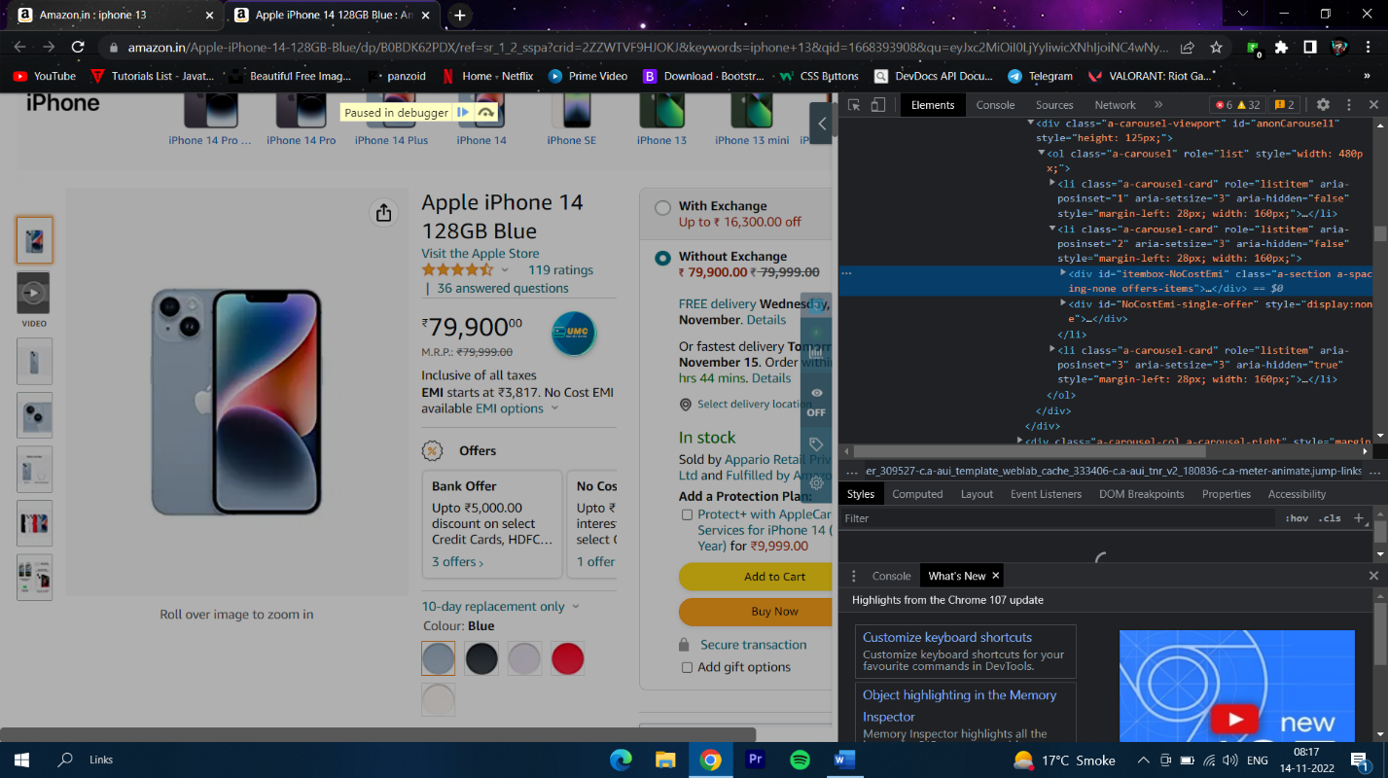

**Figure 6.1 Screenshot**

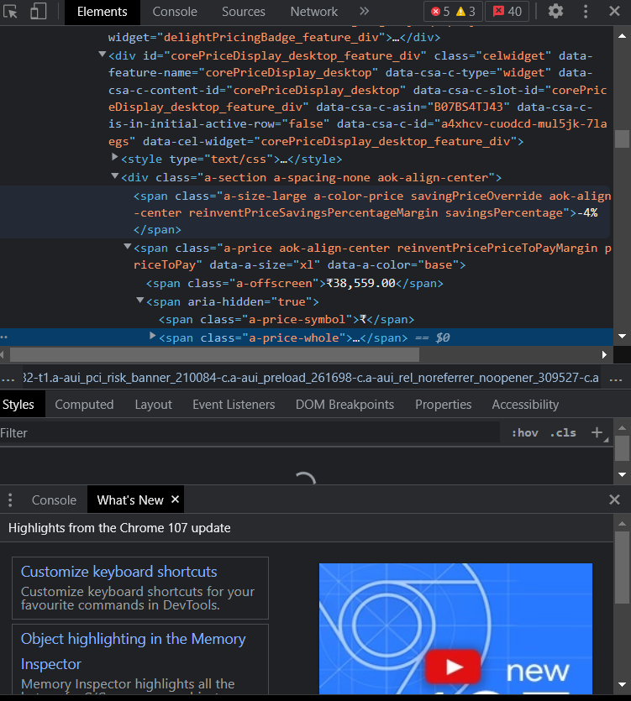

**Figure 6.2 Screenshot**



**Figure 6.3 Screenshot**

**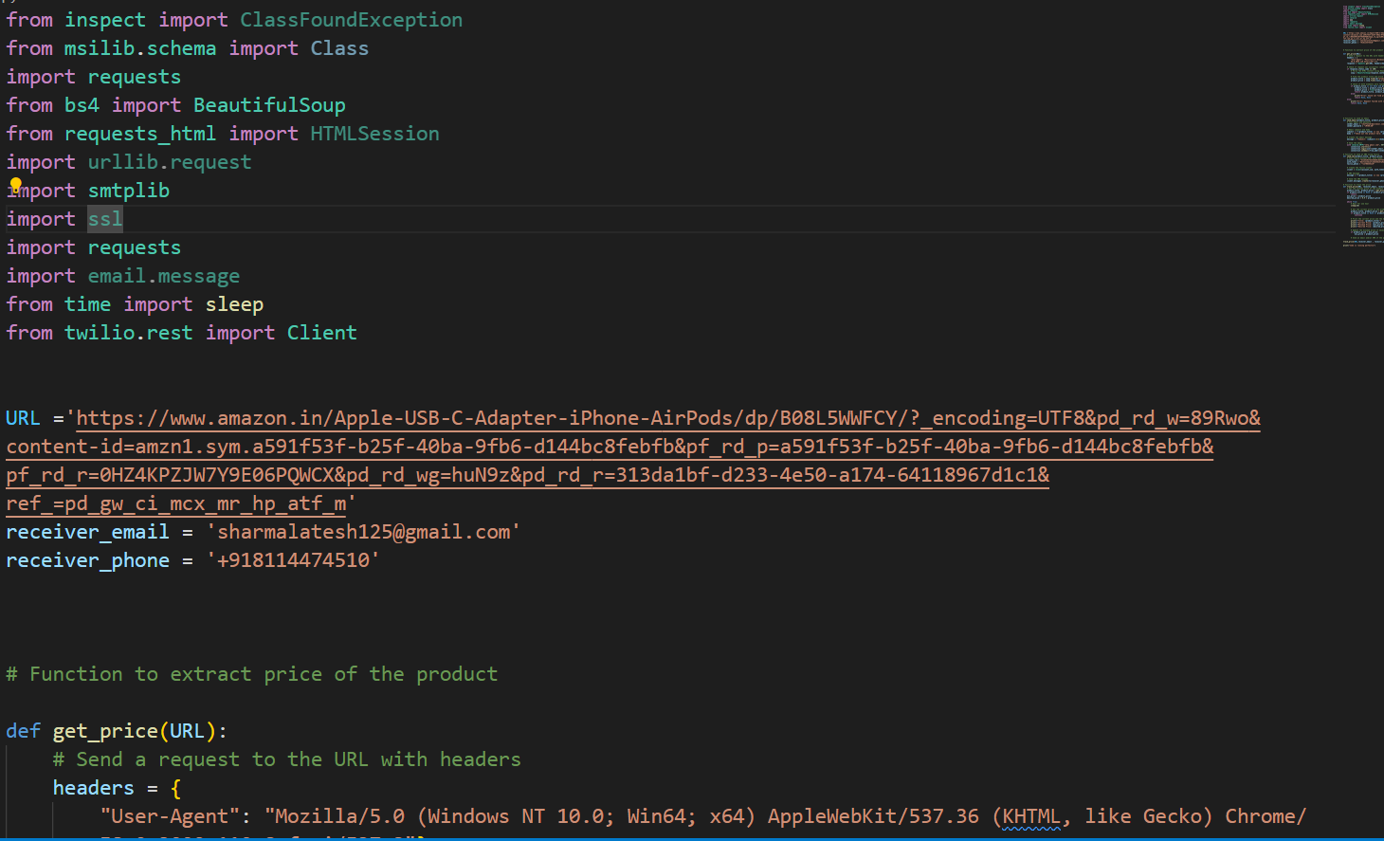**

**Figure 6.4 Screenshot**

**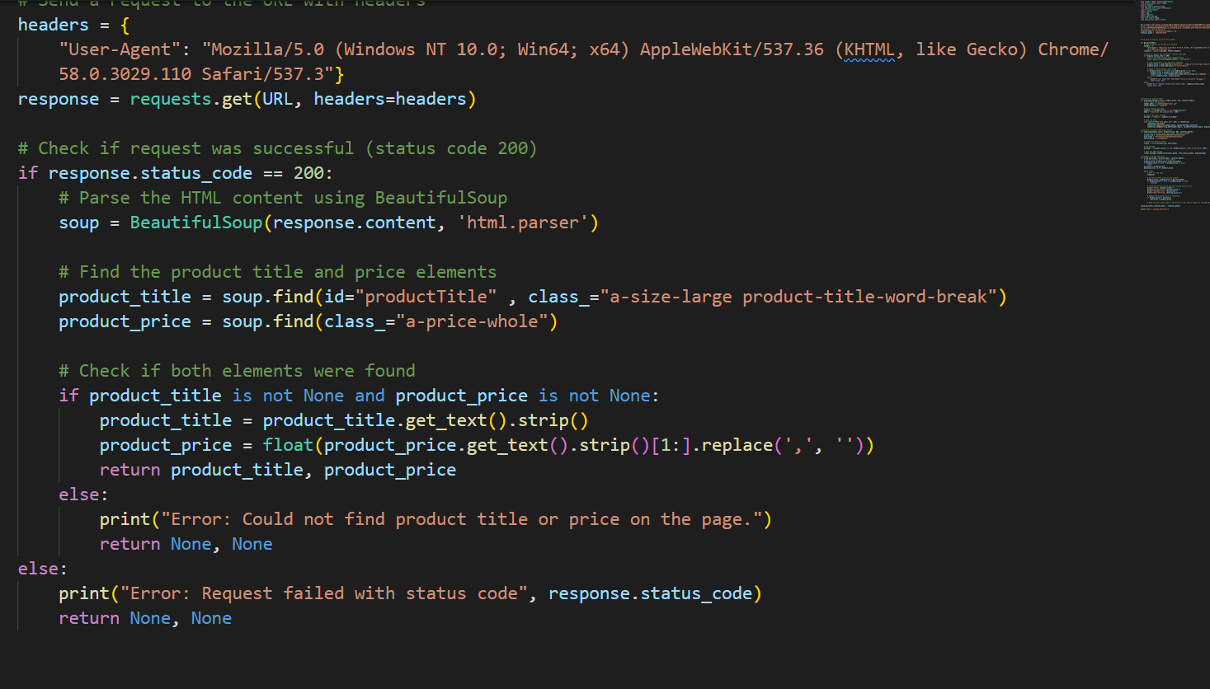**

**Figure 6.5 Screenshot**

**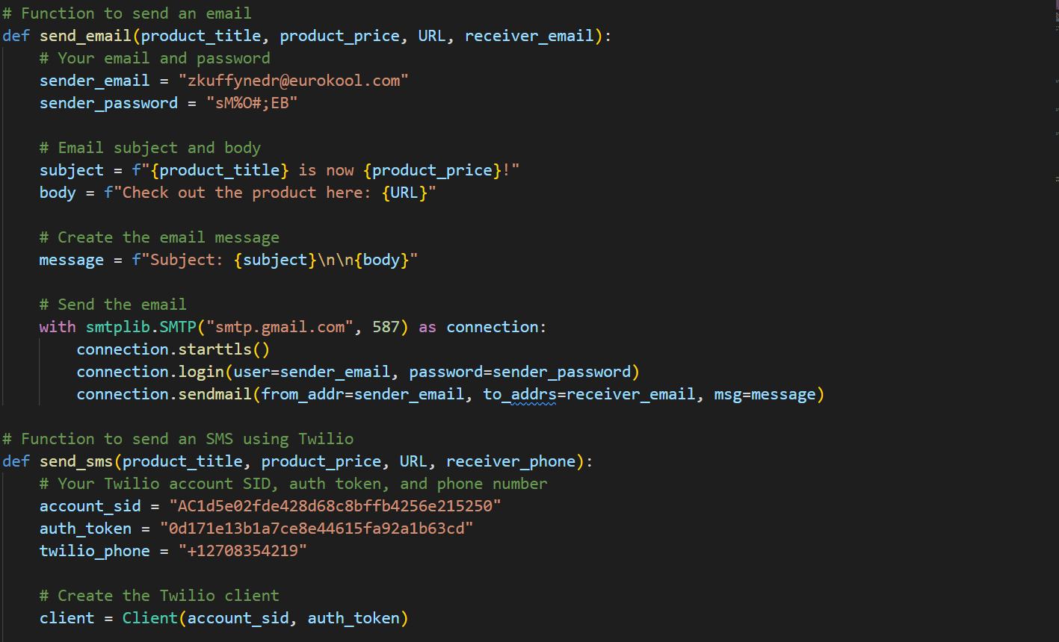**

**Figure 6.6 Screenshot**

**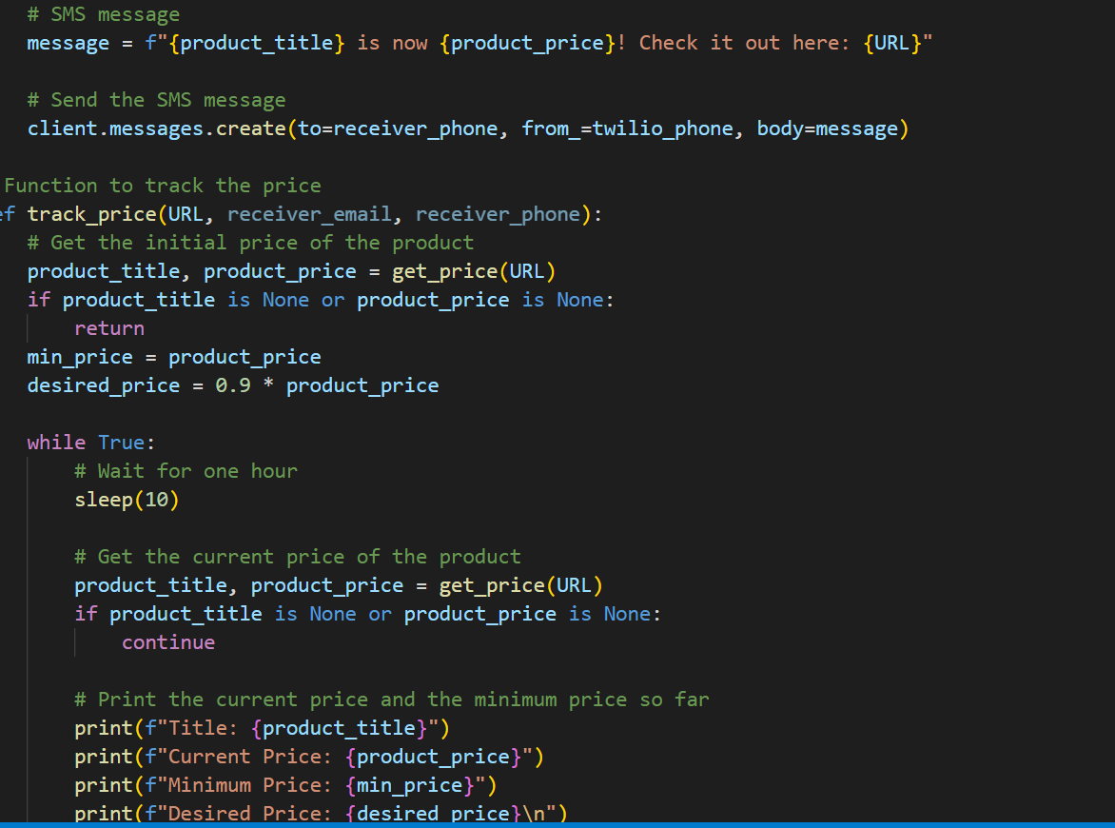**

**Figure 6.7 Screenshot**

**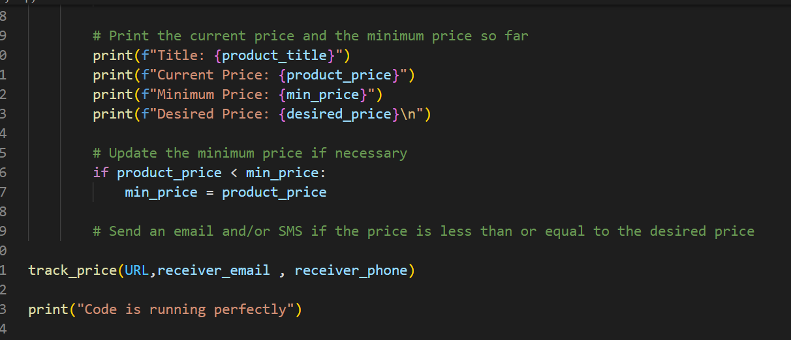**

**Figure 6.8 Screenshot**

**Chapter 7**

**Conclusion**

**7.1 Through this Internship I learned:**

Python education is well into its formative stages of development; it is evolving into a self-supporting discipline and producing professionals with distinct and complementary skills relative to professionals in the computer, information, and statistical sciences. However, regardless of its potential eventual disciplinary status, the evidence points to robust growth of Python education that will indelibly shape the undergraduate students of the future. In fact, fueled by growing student interest and industry demand, Python education will likely become a staple of the undergraduate experience. There will be an increase in the number of students majoring, minoring, earning certificates, or just taking courses in Python as the value of data skills becomes even more widely recognized. The adoption of a general education requirement in Python for all undergraduates will endow future generations of students with the basic understanding of Python that they need to become responsible citizens. Continuing education programs such as Python boot camps, career accelerators, summer schools, and incubators will provide another stream of talent. This constitutes the emerging watershed of Python education that feeds multiple streams of generalists and specialists in society; citizens are empowered by their basic skills to examine, interpret, and draw value from data.

Today, the nation is in the formative phase of Python education, where educational organizations are pioneering their own programs, each with different approaches to depth, breadth, and curricular emphasis (e.g., business, computer science, engineering, information science.

**7.2 What is the Necessity of Python?**

Data is a precious asset of any organization. It helps firms understand and enhance their processes, thereby saving time and money. Wastage of time and money, such as a terrible advertising decision, can deplete resources and severely impact a business. The efficient use of data enables businesses to reduce such wastage by analyzing different marketing channels’ performance and focusing on those offering the highest ROI. Thus, a company can generate.

Data is meaningless until its conversion into valuable information. Python involves mining large datasets containing structured and unstructured data and identifying hidden patterns to extract actionable insights. The importance of Python lies in its innumerable uses that range from daily activities like asking Siri or Alexa for recommendations to more complex applications like operating a self-driving car. The interdisciplinary field of Python encompasses Computer Science, Statistics, Inference, Machine Learning algorithms, Predictive Analysis, and new technologies. More leads without increasing its advertising spend. There are various reasons why Python is important in business. Python enables enterprises to measure, track, and record performance metrics for facilitating enterprise-wide enhanced decision making. Companies can analyze trends to make critical decisions to engage customers better, enhance company performance, and increase profitability. Python models use existing data and can simulate several actions. Thus, companies can devise the path to reap the best business outcomes. Python helps organizations identify and refine target audiences by combining existing data with other data points for developing useful insights. Python also helps recruiters by combining data points to identify candidates that best fit their company needs. In the present world, the generation and application of information is a critical economic activity. Python facilitates it with its power to extract information from large volumes of data. Information Technology makes our life easier by gathering and processing more data quickly and efficiently to provide results in hours contrary to days and weeks.

Chapter-8

Learning Outcomes Of Python

* Obtain, clean/process, and transform data.
* Analyze and interpret data using an ethically responsible approach.
* Use appropriate models of analysis, assess the quality of input, derive insight from results, and investigate potential issues .
* Apply computing theory, languages, and algorithms, as well as mathematical and statistical models, and the principles of optimization to appropriately formulate and use data analyses
* Formulate and use appropriate models of data analysis to solve hidden solutions to business-related challenges
* Perform well in a group
* Interpret data findings effectively to any audience, orally, visually, and in written formats.

**Chapter 9**

**Future scope of Python**

**Companies’ Inability to handle data**

Data is being regularly collected by businesses and companies for transactions and through website interactions. Many companies face a common challenge – to analyze and categorize the data that is collected and stored. A data scientist becomes the savior in a situation of mayhem like this. Companies can progress a lot with proper and efficient handling of data, which results in productivity.

**Revised Data Privacy Regulations**

Countries of the European Union witnessed the passing of the General Data Protection Regulation (GDPR) in May 2018. A similar regulation for data protection will be passed by California in 2020. This will create co-dependency between companies and data scientists for the need of storing data adequately and responsibly. In today’s times, people are generally more cautious and alert about sharing data to businesses and giving up a certain amount of control to them, as there is rising awareness about data breaches and their malefic consequences. Companies can no longer afford to be careless and irresponsible about their data. The GDPR will ensure some amount of data privacy in the coming future.

**Python is constantly evolving**

Career areas that do not carry any growth potential in them run the risk of stagnating. This indicates that the respective fields need to constantly evolve and undergo a change for opportunities to arise and flourish in the industry. Python is a broad career path that is undergoing developments and thus promises abundant opportunities in the future. Python job roles are likely to get more specific, which in turn will lead to specializations in the field. People inclined towards this stream can exploit their opportunities and pursue what suits them best through these specifications and specializations.

**An astonishing incline in data growth**

Data is generated by everyone on a daily basis with and without our notice. The interaction we have with data daily will only keep increasing as time passes. In addition, the amount of data existing in the world will increase at lightning speed. As data production will be on the rise, the demand for data scientists will be crucial to help enterprises use and manage it well.

**Virtual Reality will be friendlier**

In today’s world, we can witness and are in fact witnessing how Artificial Intelligence is spreading across the globe and companies’ reliance on it. Big data prospects with its current innovations will flourish more with advanced concepts like Deep Learning and neural networking. Currently, machine learning is being introduced and implemented in almost every application. Virtual Reality (VR) and Augmented Reality (AR) are undergoing monumental modifications too. In addition, human and machine interaction, as well as dependency, is likely to improve and increase drastically.

**Blockchain updating with Python**

The main popular technology dealing with cryptocurrencies like Bitcoin is referred to as Blockchain. Data security will live true to its function in this aspect as the detailed transactions will be secured and made note of. If big data flourishes, then Iot will witness growth too and gain popularity. Edge computing will be responsible for dealing with data issues and addressing them.

## **Python Careers**

The need for Python experts is thriving in every job space and is not limited to only technology. Since this is a highly in-demand career choice and guaranteed high-paying salaries, an advanced education coupled with excellent skills is mandatory. Data scientists are highly educated and boast of intelligence and a certain skill set relevant to the field. Following are some of the popular [Python careers](https://www.edureka.co/blog/data-science-career-opportunities-your-guide-to-top-data-scientist-jobs) you can crack with an advanced degree:

* Business Intelligence Developer
* Data Architect
* Applications Architect
* Infrastructure Architect
* Enterprise Architect
* Data Analyst
* Data Scientist
* Data Engineer
* Machine Learning Scientist
* Machine Learning Engineer
* Statistician

There is a distinct space and need for professionals who have insight into how a business can flourish with data have driven solutions and implementation. Python experts are required and valued in almost every field. Many businesses and even governments depend on big data to provide efficient services to their customers. The Python trend will not be taking a backseat anytime soon.

With this, we come to an end of this Future Scope of Python article. I hope you have an idea of how big is the effect of Data in our Day to Day life and how it’s going to shape our future

**References**

1. en.wikipedia.org
2. [www.simbla.com](http://www.simbla.com/)
3. [www.geeksforgeeks.org](http://www.geeksforgeeks.org/)
4. [www.runestone.academy](http://www.runestone.academy/)
5. upskillwise.com
6. [www.w3schools.com](http://www.w3schools.com/)
7. developer.mozilla.org
8. [www.html.com](http://www.html.com/)
9. [www.mygreatlearning.com](http://www.mygreatlearning.com/)
10. [www.javatpoint.com](http://www.javatpoint.com/)